الجمهورية اللبنانية
وزارة التربية والتعليم العالي | الامتحانات الرسمية لشهادة الامتياز الفني | الاسم والشهرة:--------------------
المديرية العامة للتعليم المهني والتقني =============== | دورة عام 2017 الأولى | رقم المرشح :----------------------
الاختصاص والرمز : المعلوماتية الادارية (23107)
المادة : طرائق التحليل المعدل : (12)
المستندات المسموح بها : لا شيء المدة : 3 ساعات
Treat the following exercices : (5 pts/exercise)
Exercise 1:
An enterprise should manage a set of social information concerning the children of its employees. A technician, non-professional in computer, realized the following table:

Employee First & Last Name | Address | Child 1 | Age | Child 2 | Age | Child 3 | Age
DURAND Victor | 1,rue de la liberté-13600-La Ciotat | Annie | 13 | Emile | 11
MARTIN Albert | Parc "Les Pins"-Quartier Beaufort | Jacques | 8
DUPONT Christine | 5 rue du port-13600-La Ciotat | Marc | 14 | Sylvie | 12 | Thierry | 9
DUPONT Christine | 5 rue du port-13600-La Ciotat | Aline | 4
LEBLANC Luc | Place De Gaulle-13240-Cassis | Jeanne | 9
etc…
- Indicate the weaknesses in the structure of this table.
- Realize the CDM that corrects these weaknesses.

Exercise 2:

Photography management
Studio Focus is working in the domain of photography; it aims to computerize its work as follows:
A Client is identified by an ID, has a name and a phone number, signs a contract (ID, date, total amount).
A contract may cover one or many events where each event has a sequence number starting from one, and restarts from one for every new contract. The event has a type, a location, a location type (Garden, Hotel…), and a number of photographers.
A photographer has an ID, a name and a gender.
The administration of Focus wants to know the team of photographers that executed the event and the role of each one, knowing that the same photographer may execute many roles, but only one in the same event.

Work to do:
- Establish the data dictionary (attributes, types and constraints).
- Establish the conceptual data model (CDM) by specifying the entities (identifier and properties), the relations, the cardinalities and the constraints.

Exercise 3:
Transform the following CDM into Logical Data Model (LDM).
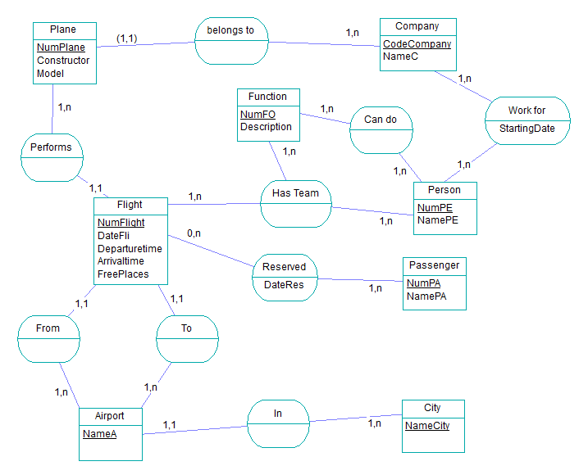

الاختصاص والرمز : المعلوماتية الادارية (23107)
المادة : طرائق التحليل

Exercise 4:
Draw the Conceptual Treatment Model of the following case:

Participation to activities
When a child arrives to the club, during the opening hours, he/she presents its ID to the cashier. The levels of activities must be classified, according to the age of the child, as follows:
- Between 8 years and 12 years : Level A
- Between 13 years and 15 years : Level B
- Between 16 years and 18 years: Level C
- Children of different ages are not allowed to participate in any activity.
After the classification, the cashier displays a list of available activities and the corresponding level for the child. The child can select a maximum of six activities, the cashier calculates the total amount and when he receives the amount from the child, the cashier will issue a ticket, puts a bracelet on the child’s hand and opens the corresponding door of activities place. The children with “Special Cases” can have a special discount.
When the child finishes playing an activity, the responsible of the activity will register “Done” for the corresponding activity. When the child returns from the place of activities, the cashier should take the bracelet, return money for non-used activities and cancel the ticket.

